SIMATS ENGINEERING
Department of Information Technology
ASSESSMENT TOOL 2 — ANSWER KEY
Course Name: Computer Networks | NAME : pattan shoib khan | Course Code: CSA0703
Course Outcome: CO1 (BL2, BL3) | REGISTER NO: 192524299 | Assessment Weightage: 30%
Annexure A — Concept Mapping

Question 1: Complete OSI Layer Chain
Application → Presentation → ______ → Transport → Network → ______ → Physical
Answer — Missing Layers
- Between Presentation and Transport → Session Layer (Layer 5)
- Between Network and Physical → Data Link Layer (Layer 2)
Completed Concept Map
Explanation of Functions
- Session Layer: Establishes, manages, synchronizes, and terminates the dialogue (session) between two communicating applications. It provides checkpoints for long transfers (e.g., resuming a file transfer) and manages full-duplex/half-duplex dialogue control. Without it, applications would have no coordinated way to open, maintain, or safely close a communication session.
- Data Link Layer: Takes packets from the Network layer and organizes them into frames, adds physical (MAC) addressing, and performs error detection (via CRC/FCS) and flow control for the single physical link. Without it, the Network layer's packets could not be reliably placed onto or read from the physical medium, and local-link errors would go undetected.
Together, these two layers close the gap between application-level dialogue management and the raw electrical/optical transmission of bits — ensuring both logical session continuity and physical-link reliability, both of which are essential for end-to-end reliable communication.

Question 2: Concept Map — Data Units vs OSI Layers
Concept Map
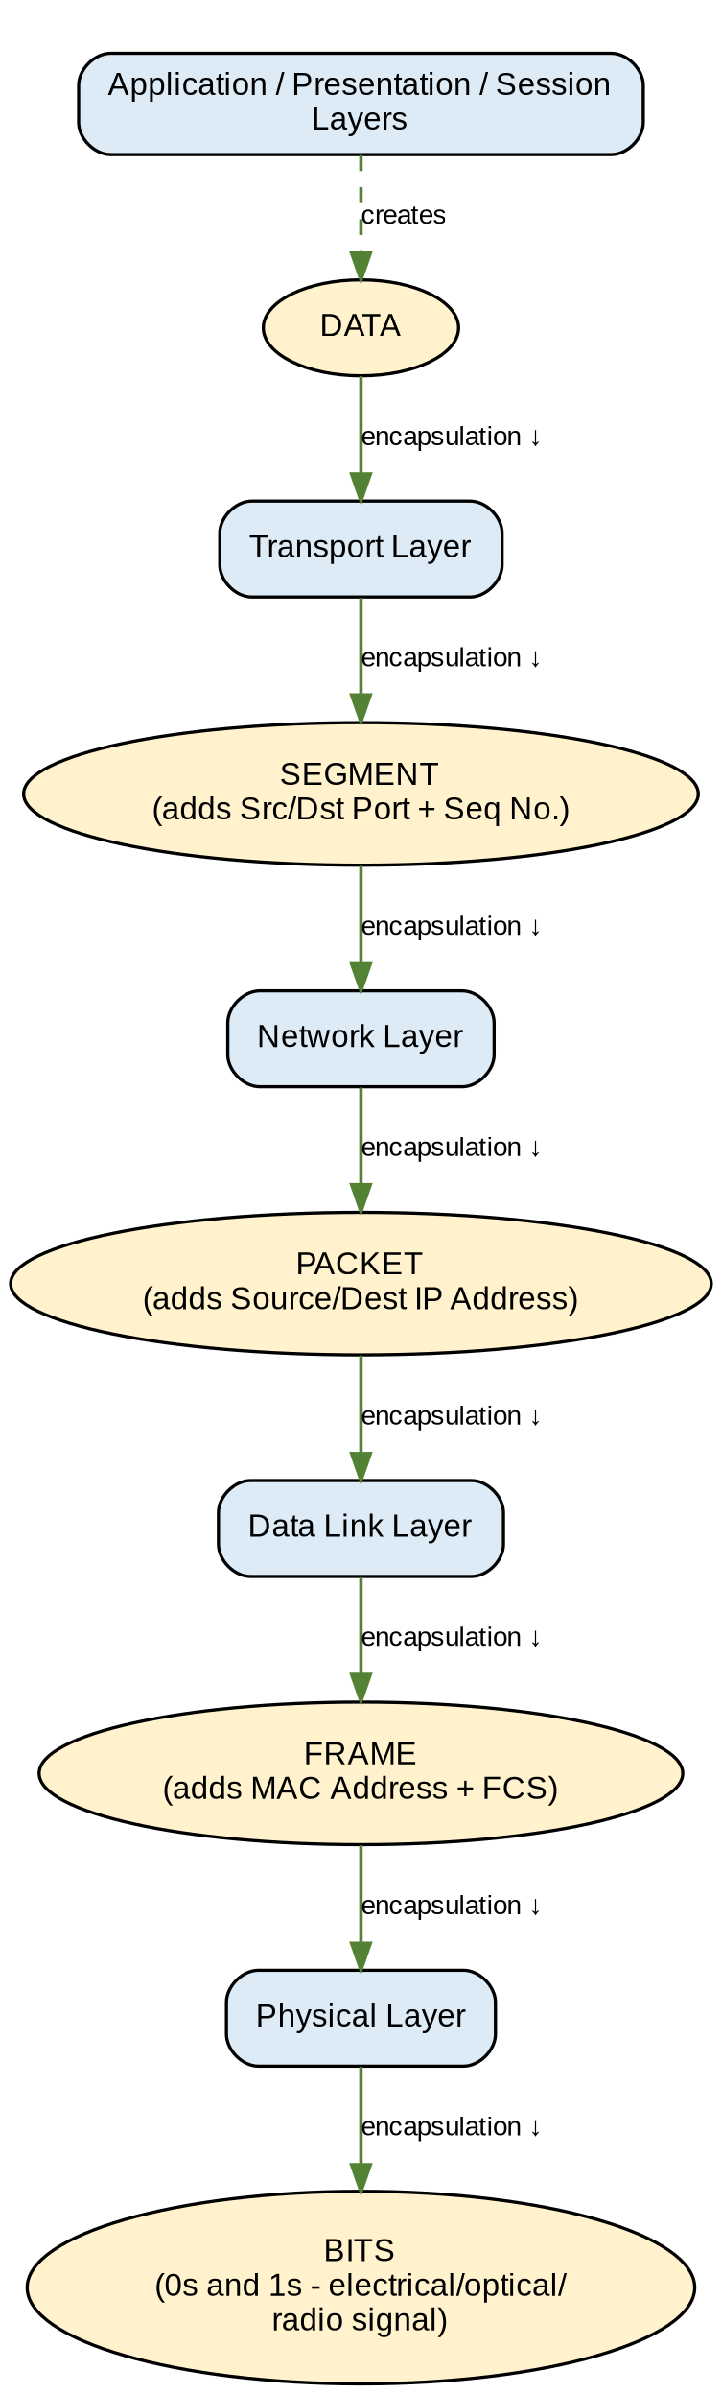
Mapping Table
OSI Layer | Data Unit (PDU) | Key Addressing Added
Application/Presentation/Session | Data | —
Transport | Segment | Port numbers, sequence number
Network | Packet | Source/Destination IP address
Data Link | Frame | Source/Destination MAC address
Physical | Bits | Electrical / optical / radio signal
Analysis — Transformation of Data Units
As data travels down the OSI stack (encapsulation), each layer wraps the unit received from the layer above with its own header (and sometimes trailer), changing its name and adding new control information:
- Data → Segment: Transport layer adds port numbers and sequencing so the receiving host can direct the data to the correct application and reorder it if needed.
- Segment → Packet: Network layer adds logical IP addressing so the unit can be routed across multiple networks to the correct destination host.
- Packet → Frame: Data Link layer adds physical MAC addressing and a trailer (FCS) so the unit can be delivered across one physical link and checked for transmission errors.
- Frame → Bits: Physical layer converts the frame into a raw bit stream (electrical, optical, or radio signals) for actual transmission on the medium.
At the receiving end, the reverse process (decapsulation) strips each header/trailer layer by layer, restoring the original data. This layered transformation allows each layer to perform its function independently while still cooperating to deliver data reliably end-to-end.

Question 3: MAC Address vs IP Address — Delivery Roles
DataLink → MAC Address → Local Delivery Network → IP Address → Global Delivery
Concept Map
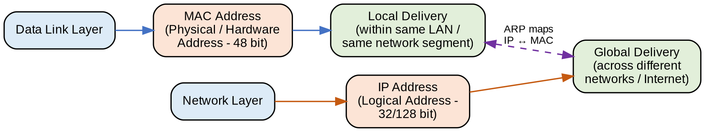
Explanation
- MAC Address (Data Link Layer): A 48-bit physical address burnt into the network interface card. It is used only for local delivery — moving a frame from one device to the next device on the same physical network/LAN segment (hop-by-hop delivery).
- IP Address (Network Layer): A logical address (32-bit IPv4 / 128-bit IPv6) that identifies a host uniquely across interconnected networks. It enables global delivery — routing a packet across multiple networks/routers from source to final destination anywhere on the internet.
- Working together: The IP address determines the overall destination network path (global routing), while at every hop along that path the MAC address (resolved via ARP — Address Resolution Protocol) is used to actually hand off the frame to the next device. The IP address stays constant end-to-end, while the source/destination MAC addresses change at every hop.
This layered division of labor — logical/global addressing at the Network layer and physical/local addressing at the Data Link layer — ensures that a data unit can be routed correctly across the internet while still being deliverable on each individual physical link, resulting in complete, correct data delivery.

Question 4: Error Control — Data Link vs Transport Layer
Error Control → Data Link Layer → Error Detection Error Control → Transport Layer → Error Correction
Concept Map
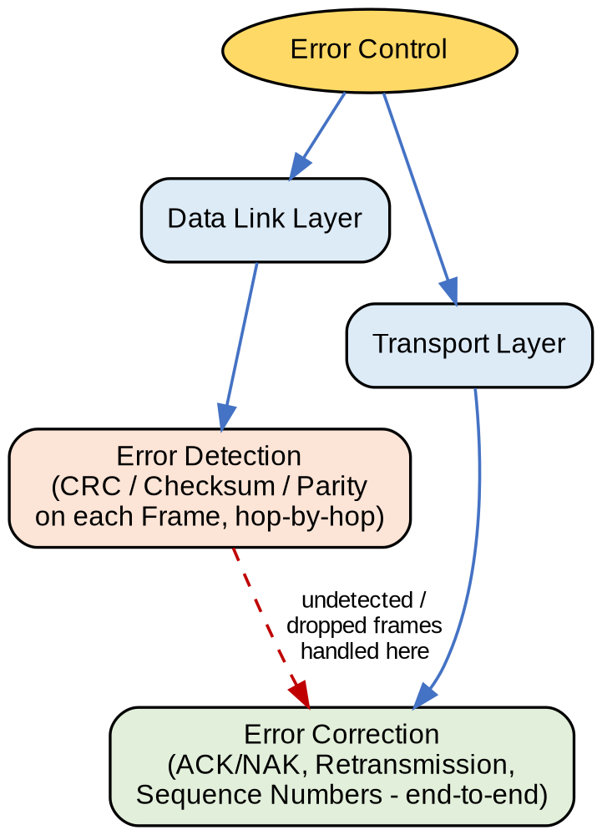
Analysis
- Data Link Layer (Error Detection): Uses techniques such as CRC (Cyclic Redundancy Check), checksum, and parity bits attached to each frame to detect whether bit errors occurred during transmission over a single physical link (hop-by-hop). If an error is detected, the corrupted frame is typically discarded — but the Data Link layer itself does not always guarantee correction/retransmission.
- Transport Layer (Error Correction): Provides end-to-end reliability using sequence numbers, acknowledgements (ACK), negative acknowledgements/timeouts (NAK/retransmission timers), and checksums. If a segment is lost, corrupted, or never acknowledged, the Transport layer (e.g., TCP) requests or performs retransmission — correcting the error from the original source all the way to the final destination.
- Interaction: The Data Link layer acts as a first line of defense — catching and discarding damaged frames close to where the error occurred (hop-by-hop), which reduces unnecessary traffic. However, since not all errors (e.g., dropped frames, congestion losses) are caught locally, the Transport layer provides an end-to-end safety net that guarantees the receiving application ultimately gets an accurate, complete copy of the data.
This two-tier error-control strategy (local detection + end-to-end correction) significantly improves overall reliability, because failures missed at one layer are still caught and resolved at the other.

Question 5: Concept Map — Web Browsing Using OSI Layers
Concept Map
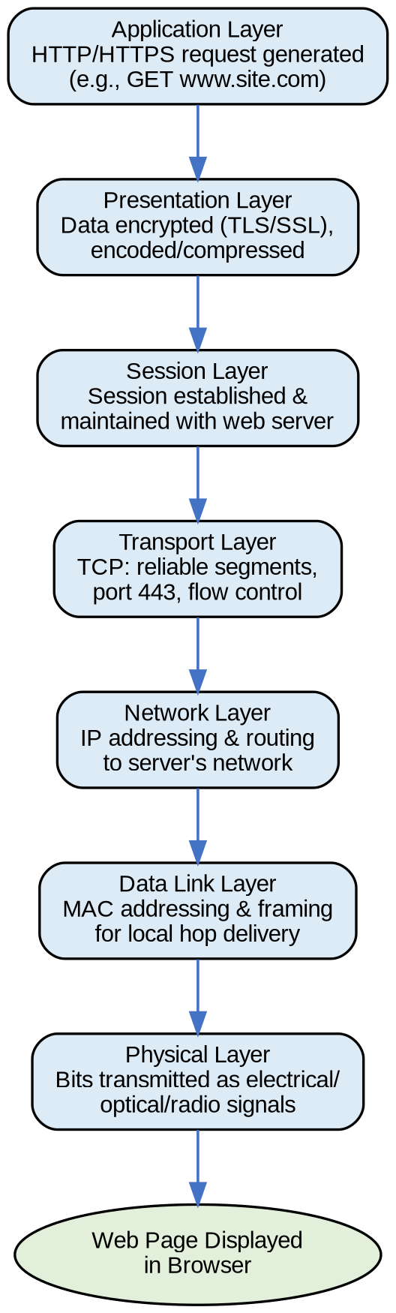
Layer-by-Layer Walkthrough
- Application Layer: Browser generates an HTTP/HTTPS request (e.g., GET www.example.com).
- Presentation Layer: Data is encrypted (TLS/SSL for HTTPS) and encoded/compressed for transmission.
- Session Layer: A session is established and maintained between the browser and the web server for the duration of the exchange.
- Transport Layer: TCP breaks data into segments, adds port numbers (e.g., port 443), and ensures reliable, ordered delivery with flow/congestion control.
- Network Layer: IP addressing and routing direct packets across intermediate networks/routers to the server's network.
- Data Link Layer: MAC addressing and framing handle delivery across each individual physical hop (e.g., LAN, ISP link).
- Physical Layer: Frames are converted to actual electrical, optical, or radio signals and transmitted over the medium (cable, fiber, Wi-Fi).
Analysis — Impact of Layer Failure
- Physical layer failure (e.g., unplugged cable, no signal): No bits can be transmitted at all — the browsing request never leaves the device.
- Data Link layer failure (e.g., MAC/framing/switch issue): Frames cannot be delivered to the next hop, so packets never reach the router even though the physical medium is intact.
- Network layer failure (e.g., bad IP config, routing failure): Packets cannot be routed to the server's network — the request is lost mid-path even if local delivery works.
- Transport layer failure (e.g., port blocked, connection reset): Reliable end-to-end delivery breaks down — data may arrive incomplete, out of order, or not at all.
- Session/Presentation layer failure (e.g., TLS handshake failure): Browser shows a security error or cannot maintain the session, even though lower layers work.
- Application layer failure (e.g., server/web-service down): The request reaches the server but no valid web page is returned to the browser.
Because each layer depends on all layers below it functioning correctly, a failure at any single layer breaks the entire chain — the browser cannot successfully load the web page even if every other layer is working perfectly. This dependency is exactly why a layered troubleshooting approach (as used in Question 6) is effective.

Question 6: Network Troubleshooting Using the Concept Map
Physical ✔ → Data Link ✔ → Network ✖ → Transport ✖ → Application ✖
Concept Map
Analysis
- Physical layer ✔: The cable/Wi-Fi connection and NIC hardware are functioning — a physical signal is present.
- Data Link layer ✔: Frames are being exchanged correctly at the local level (e.g., the device can communicate with its switch/access point using MAC addressing).
- Network layer ✖ (fault origin): Since the two layers below it work but this layer fails, the problem lies specifically at the Network layer — likely causes include an incorrect/missing IP address, wrong subnet mask, misconfigured default gateway, DNS failure, or a routing problem. The device can talk to its local network but cannot get packets routed beyond it.
- Transport layer ✖ (consequence): Because Transport-layer segments rely on Network-layer IP delivery to reach the destination, TCP/UDP connections cannot be established — this is a downstream effect, not a separate fault.
- Application layer ✖ (consequence): With no working Transport-layer connection, application requests (e.g., web browsing, email) fail — again a downstream symptom, not the root cause.
How the Concept Map Helps Troubleshooting
The concept map visually isolates exactly where the chain of dependency breaks. By checking layers from the bottom up (Physical → Data Link → Network → Transport → Application), a technician can pinpoint the first point of failure (here, the Network layer) instead of being misled by the multiple higher-layer symptoms (Transport and Application also showing ✖). This bottom-up, layer-by-layer approach is a core diagnostic strategy in real-world networking (e.g., the basis of the OSI/TCP-IP troubleshooting model), because it prevents wasted effort fixing symptoms (like restarting the browser) instead of the actual root cause (IP/routing configuration at the Network layer).

